Dynamic weather info update based on location

Month and year info

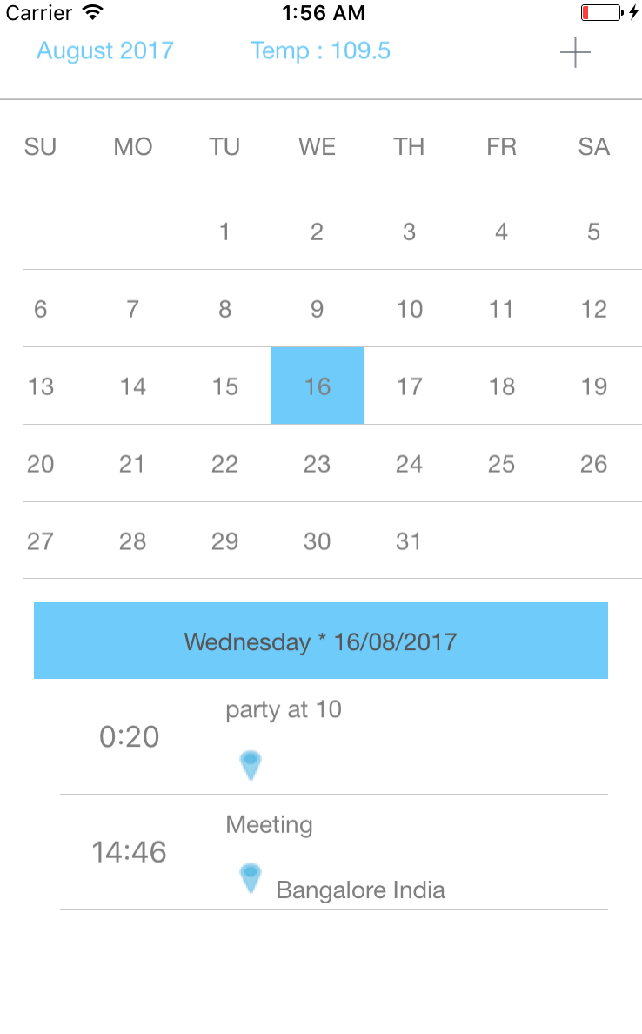

List of Events, With name, time & Location

Event Day info

Calendar control

Icon to add new event

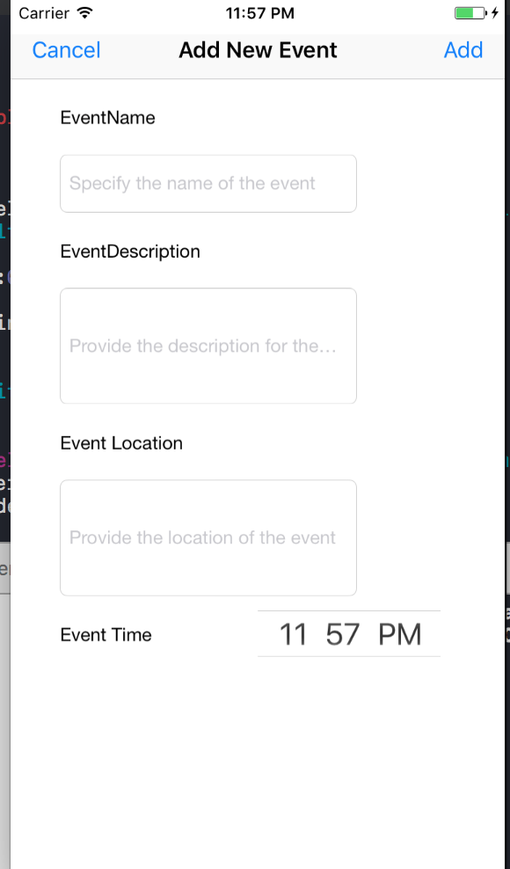

Allows user to create a new event on a specific day with time and location preferences

**Features and services in MCalendar:**

1. Calendar grid view displaying the dates of the specified month – implemented using **UITableView**
2. On Scrolling up or down, adjacent month dates will be plotted in the application
3. Tap on a date, to check the events on the specific date/day. – Data retrieval done from Coredata.
4. Way to add new event/events on any day. – data persistence done using **core data**
5. All the views are developed programmatically. No Storyboards and Xibs.
6. Display the current temperature based on the device location

* **OpenWeatherapi** is used for fetching the weather data
* Location information is retrieved using **CoreLocationDelegate**

**Limitations:**

1. XCtests are done only for critical parts of the code.
2. Orientation is restricted to Portrait.
3. Only basic calendar and agenda view has been implemented.

**Components Covered while developing MCalendar:**

* CoreLocation
* CoreData
* Networking
* UITableViews
* UIViewControllers
* UIViews and related components.
* NSNotifications
* Protocols and delegations
* Structs
* Enums
* JSON serialization
* UserConsents for accessing device information
* XCtesting
* DatePickerview